Name: _____________________________________ Date: __________________________

Analyzing Spectral Patterns

Outcome:
Can I analyze spectral patterns in order to understand how radio telescopes are used in determining characteristics of stars and star systems?

What to Do
Analyze the spectra below in order to answer the following questions.

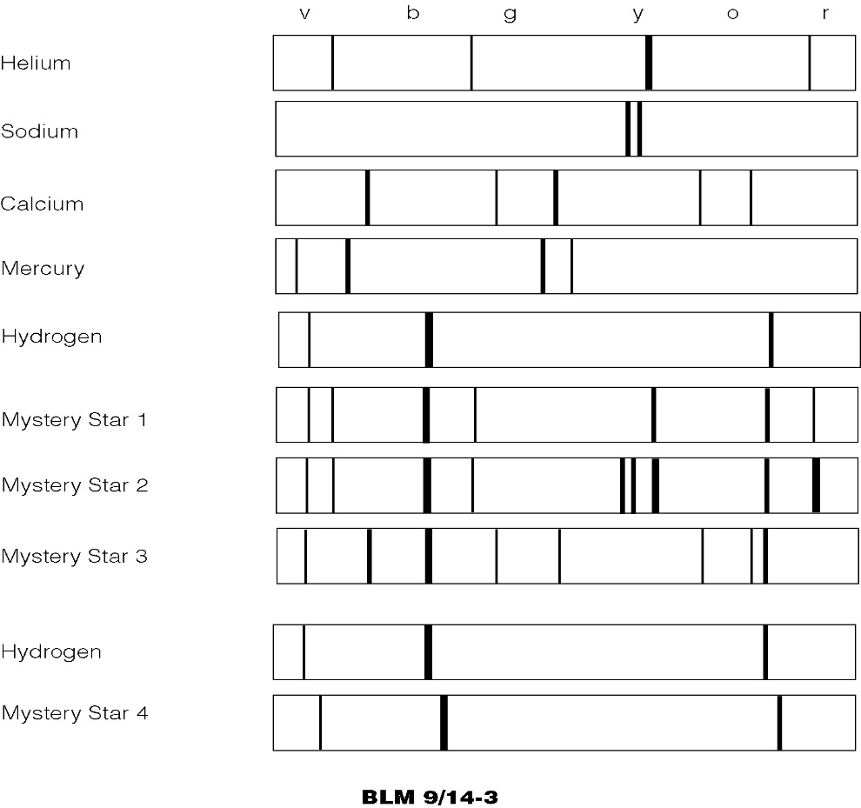

Questions

Use the space below to write answers to the questions.
2. (a) There is something strange about
Mystery Star 4’s spectrum. What
chemical is in Mystery Star 4?

- What is odd about the spectrum?

_______________________________
_______________________________

- List the chemical elements in:
- Mystery Star 1

- Mystery Star 2

- Mystery Star 3

____________________________

