Efficiency Problems

Name: _________________________ Date: ___________________ Class: _____________
General Outcome #3: Examine the power and efficiency of various devices.
- Can I calculate the amount of energy that a device uses?
- Can I apply the concepts of conservation of energy and efficiency to different devices?

- Find the efficiency of a 23 W fluorescent tube that is used 4.0 hours per day and in that time produces 6.624 x 10⁴ J (66 240 J) of useful light energy.

- A 100W incandescent bulb also produces about 6.624 x 10⁴J (66 240 J) over a 4.0 hour period. What is the efficiency of this bulb?

- Based on your answers to question 1 and 2, how much money would you save in a 30-day month if you replaced 25 of the 100 W incandescent bulbs with 23 W fluorescent bulbs? Assume that the bulbs operate 4 hours daily, and that electricity costs 10 cents per kilowatt hour.
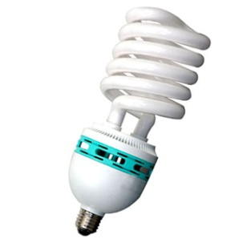
  - Fluorescent tube

  - Incandescent bulb
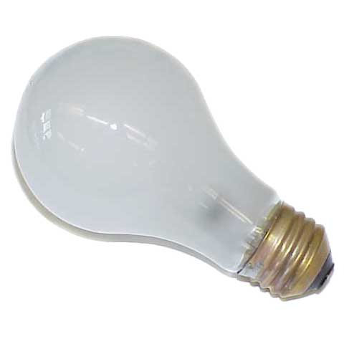

  - Savings:

