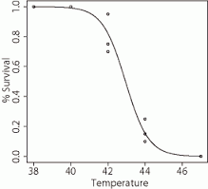

What is LD 50?

What is the LD 50 of the graph?

What is fertilizer? What are the three key components in fertilizers?

What does 5-10-12 mean on a fertilizer information sheet?

What do the root hairs of plants used for?

Calculate the PPM of 6.5 g of salt in a 350g bag.